

Microproject on the topic : 57,58.59.

-:Data system software : 2012:-

**:Features :**

* **R.D.B.M.S.** – RDBMS (Relational Database Management Systems) like Oracle, Microsoft SQL Server, IBM DB2, and MySQL were widely used for structured data management. Key trends included the rise of NoSQL databases, the adoption of in-memory databases like SAP HANA, and the integration with big data technologies. Cloud-based RDBMS services, such as Amazon RDS, were becoming more popular. RDBMS remained essential for enterprise applications due to their reliability, performance, security, and support for complex queries and analytics.
* **NOSQL database** - NoSQL databases like MongoDB, Cassandra, Redis, and Neo4j were gaining popularity for their ability to handle large-scale, unstructured data with flexible schemas and horizontal scalability. They were ideal for big data, real-time web applications, and content management. Despite their advantages, NoSQL databases faced challenges with consistency, maturity, and limited tooling compared to traditional RDBMS
* **Cloud database** - cloud databases were becoming more popular, offering scalable and easily managed solutions for data storage. Key players included Amazon RDS. These services provided automated backups high availability, and reduced administrative overhead.

**:Application :**

|  |  |
| --- | --- |
| **Applications** | **Information** |
| AgileTS Blog | A popular RDBMS known for its high performance, scalability, and robust security features. It introduced advanced features like Automatic Storage Management (ASM), Real Application Testing, and Active Data Guard, enhancing data management, backup, and disaster recovery capabilities |
| Windows Server 2012 Logo Organization Brand, logo windows 7, blue, angle  png | PNGEgg | It is an operating system designed for servers. It offers improvements in virtualization, storage, networking, and automation. Key features include Hyper-V for virtualization, enhanced Active Directory, a new file system (ReFS), and improved storage solutions. It introduced the Modern UI and focuses on cloud integration. |
| MySQL 5.6 Features | MySQL is an open-source relational database management system (RDBMS). It's widely used for web applications and data storage, known for its speed, reliability, and ease of use. MySQL supports SQL for database management and is often used in combination with PHP and Apache in the LAMP stack (Linux, Apache, MySQL, PHP/Python/Perl). |

**:Conclusion:**

In 2012, the database landscape was diverse and dynamic, with robust options catering to a wide array of needs. Traditional RDBMS like Oracle 11g, Microsoft SQL Server, IBM DB2, and MySQL remained crucial for structured data management, offering high performance, scalability, and advanced features. NoSQL databases like MongoDB, Cassandra, Redis, and Neo4j gained traction for their ability to handle large-scale, unstructured data with flexibility and high availability. Cloud databases, such as Amazon RDS, Google Cloud SQL, and Microsoft Azure SQL Database, provided scalable, cost-effective, and easily managed solutions, reflecting the growing shift towards cloud-based infrastructure. Overall, the advancements in database technologies in 2012 were geared towards enhancing performance, scalability, flexibility, and ease of management to meet the evolving demands of businesses and applications.

DATABASE SYSTEM SOFTWARE 2013

**:Features:**

* **Enhanced SQL features** : SQL databases introduced several key enhancements to boost performance, scalability, and flexibility. SQL Server 2012 added columnstore indexes for faster data warehousing, new T-SQL functions, and AlwaysOn Availability Groups for high availability. Oracle 12c introduced a multitenant architecture for easier management, the MATCH_RECOGNIZE clause for pattern matching, and adaptive query optimization.
* **NOSQL advancement :** NoSQL databases saw significant advancements aimed at improving performance, scalability, and integration with big data technologies. MongoDB enhanced its aggregation framework, added text search capabilities, and strengthened security features. Cassandra introduced a better query language (CQL3), improved secondary indexes, and enhanced Hadoop integration. Redis 2.8 brought improved clustering and replication features, boosting its real-time capabilities. HBase focused on better performance and scalability, along with improved integration with Hadoop and support for complex queries. Neo4j advanced its Cypher query language and enhanced graph processing performance
* **Big data integration :** big data integration saw significant advancements as organizations increasingly sought to harness large volumes of diverse data. Key technologies like Hadoop and Apache Spark gained widespread adoption for their ability to process and analyze massive datasets efficiently. Integration between traditional RDBMS and big data platforms improved.

**:Application:**

|  |  |
| --- | --- |
| **Applications** | **Information** |
| Oracle Database 12c Administration 1Z0-062 Test | It introduced several key features, including a multitenant architecture that allows multiple pluggable databases within a single container database for easier management and consolidation. It also featured improved SQL pattern matching with the MATCH_RECOGNIZE clause. |
| Understanding the 2014 Microsoft SQL Server - Windows VPS Hosting Blog -  AccuWeb Hosting | Microsoft SQL Server continued to be widely used, primarily featuring updates from SQL Server 2012. Key enhancements included columnstore indexes for faster data warehousing queries, AlwaysOn Availability Groups for high availability and disaster recovery, and improved T-SQL functions for better data handling and pagination. |
| mysql : create database and table | It brought significant improvements including enhanced performance and scalability, better JSON support, a new query optimizer, and improvements to replication and security. |

**:Conclusion:**

The landscape of data system software was marked by significant innovations aimed at enhancing performance, scalability, and flexibility. RDBMS continued to evolve with features catering to enterprise needs, while NoSQL databases gained traction for their ability to handle unstructured data and provide high availability. The integration of big data technologies with traditional databases became more seamless, enabling businesses to leverage comprehensive analytics and gain deeper insights from their data. These advancements reflected a broader trend towards more powerful, scalable, and versatile data management solutions to meet the growing demands of modern applications and data-driven decision-making.

DATA SYSTEM SOFTWARE 2015

:**Features**:

* **Hybrid data base solutions :** Hybrid database solutions emerged as a prominent trend, combining the strengths of both traditional relational databases (RDBMS) and NoSQL databases. These solutions aimed to provide the scalability and flexibility of NoSQL systems, which are ideal for handling unstructured and semi-structured data, while retaining the reliability and robust transactional support of RDBMS. Hybrid databases allowed organizations to leverage the best of both worlds, supporting a variety of workloads and data types within a single, integrated environment
* **In memory computing :** In-memory computing emerged as a powerful technology trend, significantly enhancing the performance and speed of data processing by storing data directly in the main memory (RAM) of servers. This approach allowed for real-time analytics and accelerated transaction processing, addressing the limitations of traditional disk-based storage systems. By reducing data retrieval times and leveraging parallel processing, in-memory computing facilitated faster decision-making and improved the efficiency of applications in various sectors, including finance, telecommunications
* **Security :** Database security was a critical concern due to the increasing frequency and sophistication of cyber-attacks. Key issues included vulnerabilities in database management systems, the rise of SQL injection attacks, and insufficient encryption practices.

**:Application:**

|  |  |
| --- | --- |
| **Applications** | **Information** |
| Installing and Running Postgresql on Manjaro OS | by iraj | Medium | Introduced several significant features to enhance performance and usability. Key improvements included the addition of the UPSERT functionality (INSERT ON CONFLICT DO UPDATE), which allowed for more efficient handling of conflicts during data insertion. Other notable features were row-level security, which provided more granular access control, and enhanced JSONB capabilities for better handling of JSON data |
|  | MongoDB 3.0 introduced significant improvements, including the WiredTiger storage engine, which enhanced performance and efficiency with better compression and concurrency control. This version also brought improved security features like role-based access control, better scalability, and more flexible data management capabilities. |
|  | Redis 3.0, released in April 2015, introduced significant improvements and features to the in-memory data structure store. Notably, it included support for Redis Cluster, enabling automatic sharding for horizontal scalability across multiple nodes. |

**:Conclusion:**

In 2015, data system software evolved significantly to address the increasing demands for scalability, performance, and security. Innovations in database technologies, such as the introduction of Redis 3.0 with Redis Cluster, exemplified efforts to enhance scalability and fault tolerance. Concurrently, the heightened awareness of security threats led to more robust measures in database management practices. The year marked a pivotal moment where advancements in data system software not only improved operational efficiency and real-time data processing but also underscored the critical importance of securing sensitive information against growing cyber threats.

DATA SYSTEM SOFTWARE 2016

**:Features:**

* **Advanced analytics and machine learning** : advanced analytics and machine learning gained significant traction, transforming how organizations leveraged data. Machine learning algorithms, powered by increased computational capabilities and vast datasets, enabled more accurate predictive models and real-time analytics. The rise of deep learning, particularly neural networks, facilitated breakthroughs in image and speech recognition.
* **Improved security and compliance:** improved security and compliance in the tech industry focused on enhancing data protection and meeting regulatory standards. Companies adopted advanced encryption techniques, multi-factor authentication, and more sophisticated intrusion detection systems. Compliance efforts were driven by stricter regulations such as GDPR and HIPAA, leading to more rigorous data handling practices.
* **Semi – structured data** : semi-structured data gained significant attention due to the rise of big data and the need for more flexible data management solutions. Unlike structured data, which fits neatly into tables and rows, semi-structured data does not adhere to a strict schema, allowing for more variability and adaptability. Common formats for semi-structured data include JSON, XML, and NoSQL databases.

**:Application:**

|  |  |
| --- | --- |
| **Applications** | **Information** |
| SQL Server 2016 release: What new does it have to offer? – AIM | Microsoft SQL Server 2016, released in June 2016, introduced several advanced features and improvements focused on performance, security, and analytics. Key enhancements included real-time operational analytics, advanced data integration capabilities, and in-memory columnstore for high-speed analytics. |
| Download Redis Logo in SVG Vector or PNG File Format - Logo.wine | Redis 3.2, released in May 2016, introduced several enhancements to the popular in-memory data structure store. Key features included improvements in Redis Cluster stability and performance, new commands such as BITFIELD for manipulating binary data, and enhancements to existing commands for better usability and efficiency. Additionally, Redis 3.2 brought better memory management, improved Lua scripting capabilities, and more robust support for HyperLogLog and Streams. |

:Conlcusions:

In 2016, data system software continued to evolve rapidly, driven by the need for advanced analytics and the integration of machine learning capabilities. The year saw significant improvements in data processing, storage, and real-time analysis, empowering organizations to extract deeper insights and make more informed decisions. Enhanced scalability, performance, and security measures became standard, addressing the growing complexity and volume of data. The widespread adoption of machine learning and AI technologies further revolutionized data systems, enabling more sophisticated predictive analytics and automation.

DATA SYSTEM SOFTWARE 2017

**:Features:**

* **Integration of the AI and machine learning :** The integration of AI in the field of databases began to gain significant traction, with a focus on enhancing data management and analytics. AI-driven techniques were employed to automate database tuning, improve query optimization, and enable predictive analytics. Machine learning algorithms helped in anomaly detection, data cleansing, and pattern recognition, making databases more efficient and reliable. Additionally, natural language processing (NLP) was increasingly used to facilitate more intuitive database queries, allowing users to interact with databases in more human-like ways. This integration marked a pivotal shift towards more intelligent, self-managing database systems.

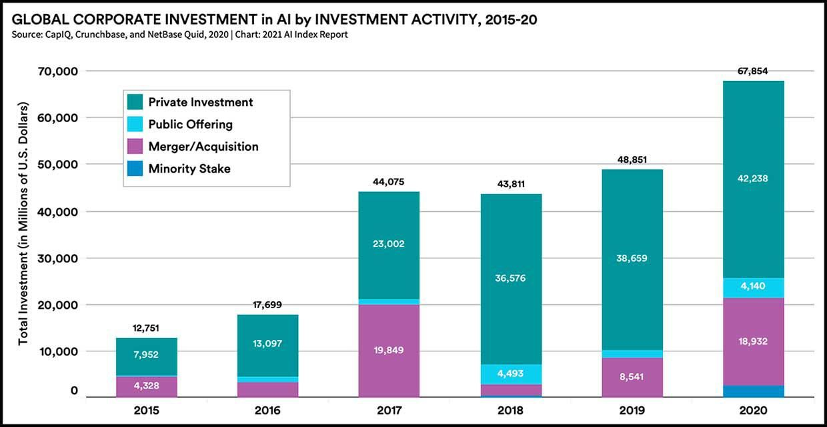

**:Application:**

|  |  |
| --- | --- |
| **Application** | **Information** |
| Where are the "official" SQL 2017 logo's? – SQLServerCentral Forums | Microsoft SQL Server 2017 is a relational database management system that supports a variety of data types and services, including structured, semi-structured, and spatial data. It introduced support for running SQL Server on Linux, containerization with Docker, and integrated machine learning capabilities with R and Python. The 2017 version also improved performance, security features, and introduced adaptive query processing to optimize query execution dynamically. |
| MySQL 8.0.26 and 5.7.35 Released - PHP Magazine Network | MySQL 8.0 is a major release of the popular open-source relational database management system. It introduces several enhancements, including improved performance, better security features, and enhanced SQL capabilities. Key features include window functions, common table expressions (CTEs), JSON improvements, and support for Unicode 9.0. |
| cassandra 3.11 end of life - Azure Cosmos DB Blog | Cassandra 3.11 is a version of the Apache Cassandra database, a highly scalable, distributed NoSQL database designed for handling large amounts of data across many commodity servers. Released in August 2017, Cassandra 3.11 focused on performance improvements, including faster read and write operations, better compaction strategies, and enhanced caching. |

**:conclusion:**

In 2017, database management systems (DBMS) saw significant advancements driven by the growing demand for handling large-scale, diverse data in real time. The year marked a shift towards more flexible, scalable solutions, with NoSQL databases like Apache Cassandra and MongoDB gaining prominence alongside traditional relational databases such as MySQL and PostgreSQL. Hybrid systems that combined SQL and NoSQL features also emerged, reflecting the need for versatile data management across different use cases. Additionally, cloud-based DBMS options became increasingly popular, offering organizations greater agility, scalability, and cost efficiency. Overall, 2017 was a pivotal year for DBMS innovation, emphasizing performance, scalability, and adaptability to meet the evolving needs of businesses.